**Python Digital Assignment 1**

***Name: Harsh kumar srivastava***

***RegNo:22MCA0310***

**Question 1**

A team of authorities designed by Govt. of India to conduct a survey on Colleges. Let us assume ‘n’ number of colleges. They were asked to rank the colleges based on 3 different parameters. The parameters are facilities, academics and infrastructure. Maximum score in each parameter is as follows.

Facilities=25

Academics=50

Infrastructure=25

At the end of the survey the scores of the individual parameters are added up to get the total score and the colleges are ranked based on the score. The college that scores the highest score is ranked first. Next highest score is given the rank second and so on. Write a program to read the scores of the three parameters for each college, store the scores in a list. Make a list of individual score list for ten colleges. Find the total score for all ten colleges, and sort them. Print the Total score in the sorted (Descending) order. You have to use any sorting method for sorting.

**Input format:**

Read the scores for facilities for College 1

Read the scores for academics for College 1

Read the scores for infrastructure for College 1

Read the scores for facilities for College 2

Read the scores for academics for College 2

Read the scores for infrastructure for College 2

--

---

Read the scores for facilities for College 10

Read the scores for academics for College 10

Read the scores for infrastructure for College 10

**Output format:**

Total score in the sorted order (Descending)

**Solution:-**

*# Create a list to store the scores of n colleges*

scores = []

*# Loop to read the scores of three parameters for each college*

n=int(input("no of colleges"))

for i in range(n):

    print("Enter the scores of facilities, academics and infrastructure for college ", i+1)

    facility_score = int(input("facility score: 25/"))

    academics_score = int(input("academics score:50/"))

    infrastructure_score = int(input("infrastructure score:25/"))

    total_score = facility_score + academics_score + infrastructure_score

    scores.append(total_score)

*# Sort the scores in descending order*

scores.sort(reverse=True)

*# Print the sorted scores*

print("Total scores of colleges in descending order:")

for i in range(n):

    print("College ", i+1,scores[i])

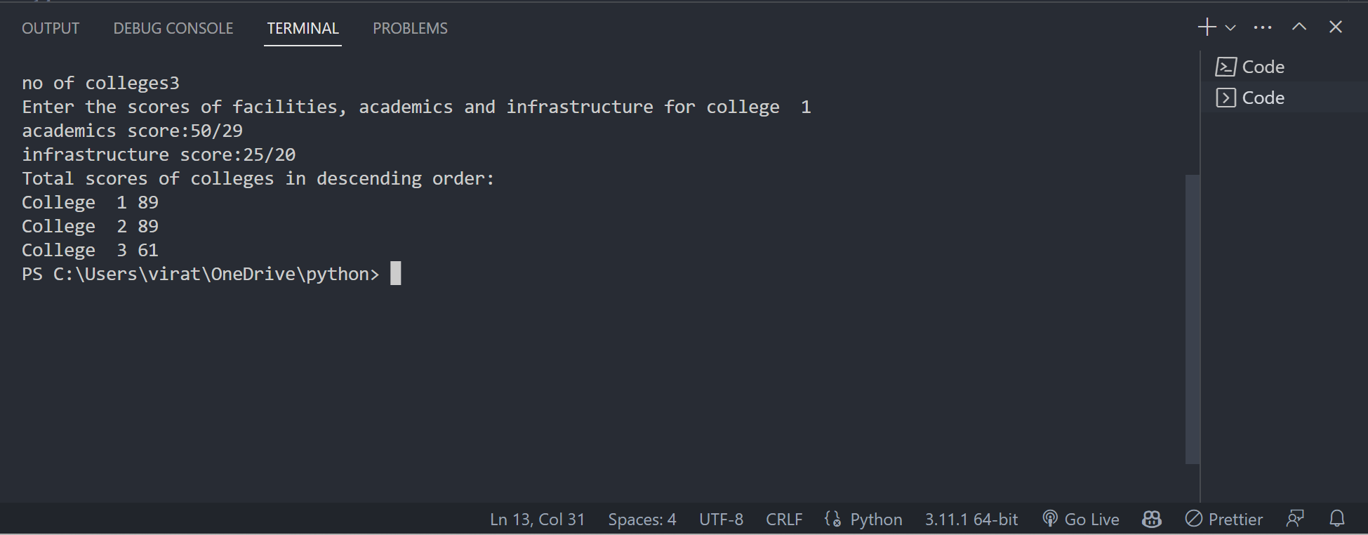

**Question 2**

Students in a class are appreciated based on the following factors

Number of 'S' grade >= 3

Attendance >= 90

Participation in sports activity in a semester >= 2

Appreciation is given as follows:

(i) 'Excellent' if all three conditions are met

(ii)'Very Good' if conditions (i) and (ii) are met

(iii)'Good' if conditions (i) and (iii) are met

Given the Number of 'S' grades, Attendance and Participation in sports activity in a semester, write the python code to output the appreciation for the student. Check boundary conditions and print 'Invalid input' for wrong input.

**Boundary Condition:**

All values of input >= 0

**Solution**

s  = int(input("enter no of S grades"))

a  = int(input("enter Attendance in percentage"))

p= int(input("No of sports activity participated"))

if s<=0 or a<=0 or p<=0:

   print("Invalid Input")

   exit()

if s>=3 and a>=90 and p>=2:

    print("Excellent")

elif s>=3 and a>=90 and p<2:

    print("Very Good")

elif s>=3 and a<90 and p>=2:

    print("Good")

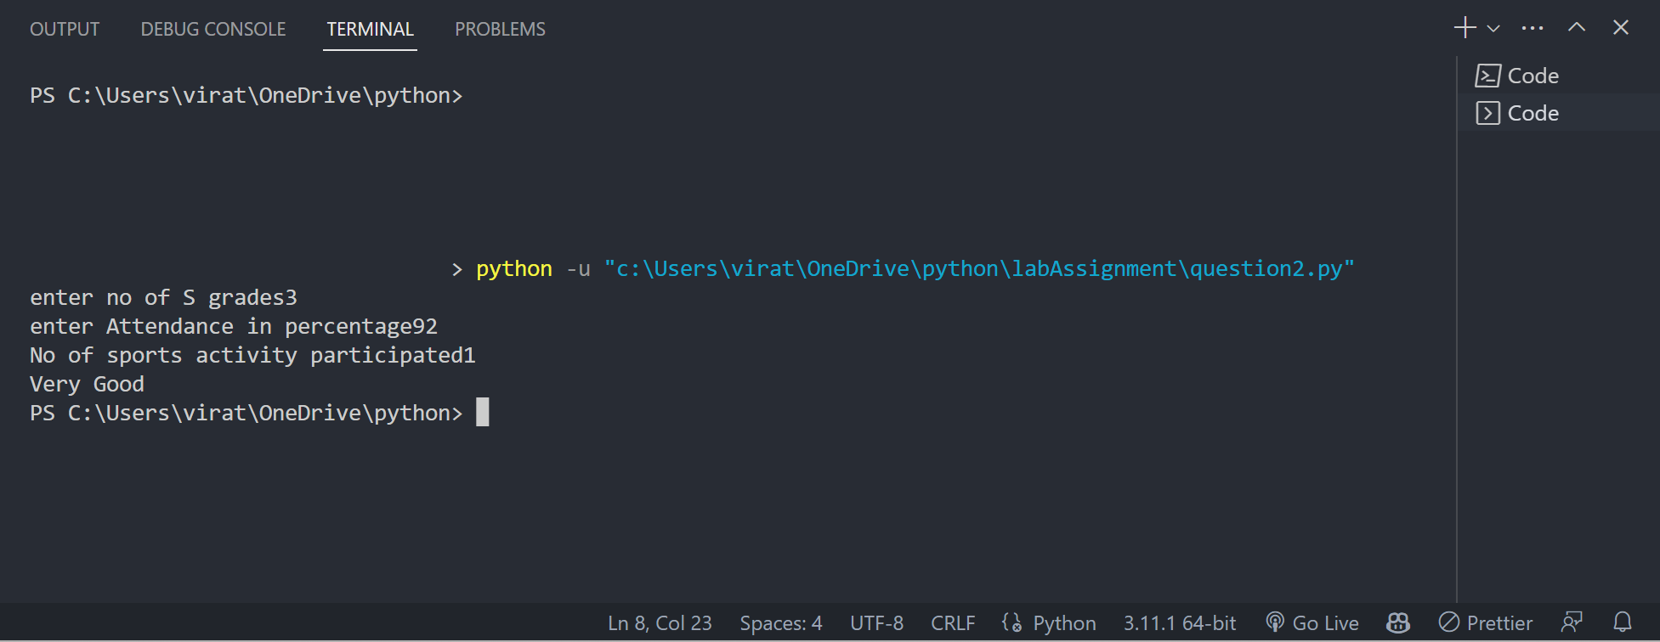

A man engaged 'n' labourers to make ’t’ toys in ’d’ days. Assume that all men work with same speed and efficiency. After 'd1' days, he found that only 't1' toys were made. Design an algorithm and write a Python code to determine the number of additional men to be employed to complete the task in time. For example, if n is 10, t is 320, d is 5, d1 is 3, and t1 is 120 then the number of additional men to be employed is 12. Assume that the speed of making toys is uniform for all men.

**Input Format:**

Read the number of labourers engaged in work

Read the total number of toys to be made (t)

Read the total number of days allotted for completion (d)

Read the number of days work had been done (d1)

Read the number of toys made in d1 days (t1)

**Output Format:**

Number of more men required for completing the job in allotted period

**Solution**

n = int(input("enter no of workers"))

target_Toys=int(input("enter no of toys"))

day =int(input("enter no of days"))

Toys_made=int(input("enter no of toys made"))

day_passed=int(input("enter no of days passed"))

produtionPerDay=Toys_made/day_passed

menWorkPerDay=produtionPerDay/n

worksLeft=target_Toys-Toys_made

daysLeft=day-day_passed

reqWorkForce=daysLeft*menWorkPerDay

totalMenRequired=worksLeft/reqWorkForce

RemainingMen=totalMenRequired-n

print("Extra Men required",RemainingMen)

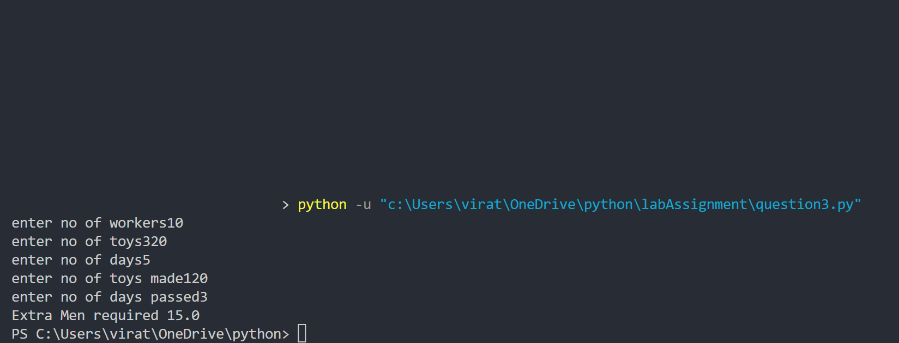

**Question 4**

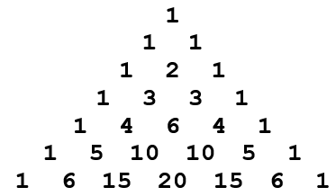Write a python program that prints Pascal’s triangle

**Solution:**

number = int(input("Enter the number: "))

store = [] *#an empty list*

for i in range(number):

  store.append([])

  store[i].append(1)

  for j in range(1, i):

    store[i].append(store[i - 1][j - 1] + store[i - 1][j])

  if(number != 0):

    store[i].append(1)

for i in range(number):

  print(" " * (number - i), end = " ", sep = " ")

  for j in range(0, i + 1):

    print('{0:6}'.format(store[i][j]), end = " ", sep = " ")

  print()

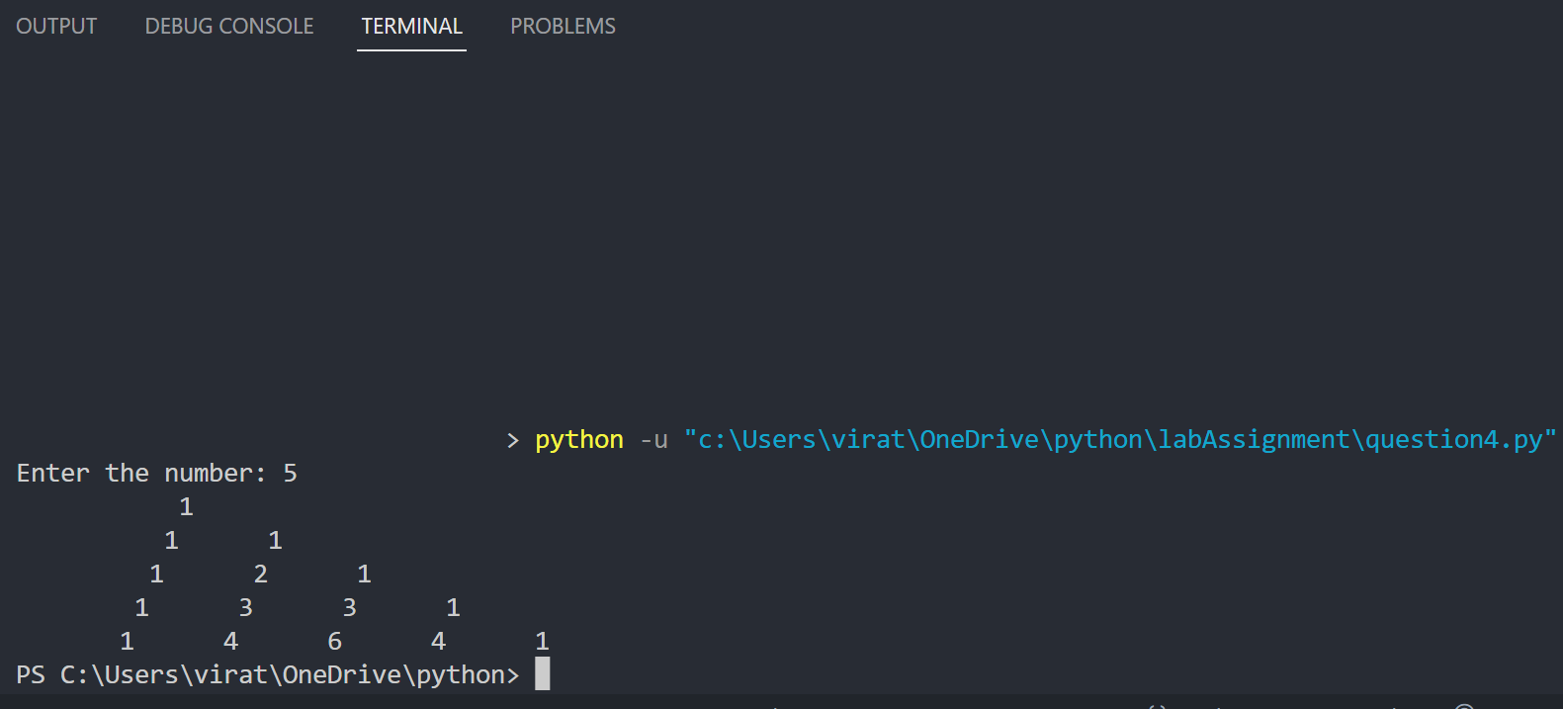

**Question 5**

VIT follows relative grading based on the class average to grade the performance of students in various examinations. Write a program that accepts the marks secured by a student for a given subject along with the average marks of the respective class. Then display the grade he has secured, based on the following instructions.

1. Grading is done based on the deviation from class average.
2. If the deviation from class average of the student’s mark is greater than or equal to 20, the student has scored S grade
3. If the deviation from class average of the student’s mark is greater than or equal to 10, the student has scored A grade
4. If the deviation from class average of the student’s mark is within the range of -5 to + 5, the student has scored B grade
5. If the deviation from class average of the student’s mark is less than or equal to 10, the student has scored C grade
6. If the deviation from class average of the student’s mark is less than or equal to 15, the student has scored D grade
7. If the deviation from class average of the student’s mark is less than 20, the student has scored F grade

**Solution**marks = []

sd_cal = []

sd_cal2 = []

total_students = int(input("Enter the total number of students : "))

total_marks = 0

total_mark_sqr = 0

mrks = 0

for i in range (0,total_students):

    student_marks = int(input("Enter the marks of student "+ str(int(i + 1)) +": "))

    marks.append(student_marks)

for i in range (0,total_students):

    total_marks = total_marks + marks[i]

avg_marks = int(total_marks / total_students)

for i in range (0,total_students):

    mark = marks[i] - avg_marks

    sd_cal.append(mark)

    mark_sqr = mark * mark

    sd_cal2.append(mark_sqr)

for i in range (0, total_students):

    mrks = mrks + sd_cal[i]

for i in range (0, total_students):

    total_mark_sqr = total_mark_sqr + sd_cal2[i]

variance = total_mark_sqr / (total_students - 1)

sd = variance**0.5

md = mrks / total_students

md_by_mean = md / avg_marks

print(sd_cal)

print(sd_cal2)

print(sd)

print(mrks)

print(md)

print(md_by_mean)

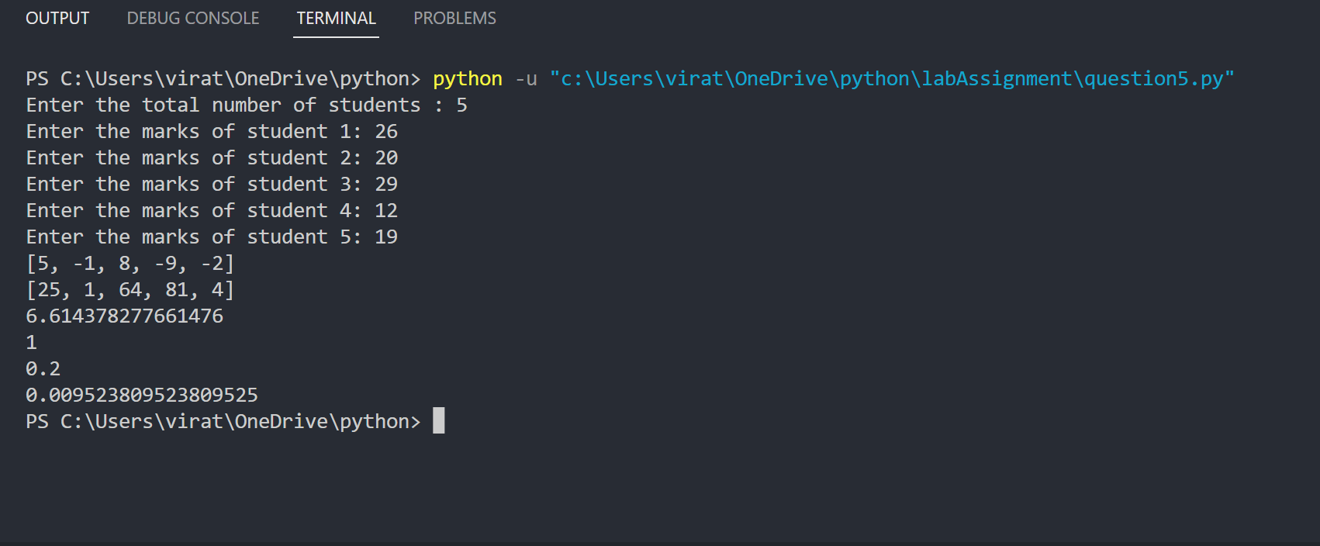

**Question 6**

A company wants its employees to work for 'X' hours on average per day in a week (Monday to Friday). Given the number of hours worked by an employee on each day of a week, design a flowchart and write a Python code to compute the average number of hours worked by the employee. Number of hours worked can be floating point values. For example, 7 hours 30 minutes is entered as 7.5 hours

**Input Format:**

Number of hours worked on first day

Number of hours worked on second day

Number of hours worked on third day

Number of hours worked on fourth day

Number of hours worked on fifth day

**Output Format:**

Average hours worked in a week

**Solution**

working_hrs = []

weekly_hrs = 0

working_days = int(input("No of working days: "))

for i in range(0,working_days):

    daily_hrs = float(input("Working hours on day "+ str(int(i+1)) +" : "))

    working_hrs.append(daily_hrs)

for i in range(0,working_days):

    weekly_hrs = weekly_hrs + working_hrs[i]

avg_working_hrs = weekly_hrs / working_days

print("Average  working time(in Hrs) :", avg_working_hrs)

